PUBLIC CREDIT
OPPORTUNITY ENGINE

User Guide
A page-by-page walkthrough of every screen, control and figure on the platform, illustrated with the live interface
August 2026
Platform reference — standalone

Contents
1. How to Read This Guide
2. The Global Opportunity Map
3. The Opportunity Board
4. Spread Minus Expected Loss
5. VAR Forecast & Contagion
6. Returns — Buy-and-Hold and Volatility Strategy
7. Actual History
8. Model Drivers
9. Recommendations — Unsupervised Classification
10. Signals — What Goes Live Next
11. Using the Platform as a Whole

1. How to Read This Guide
This guide walks through every screen of the platform in the order the navigation bar presents them, using screenshots taken directly from the live site. It explains what each control does, what every column and card means, and how the figures on screen are meant to be read — without referring to any underlying file, script or piece of code. It is meant to be read on its own, whether or not the reader ever opens the platform itself.
A companion document, the Quantitative Methodology reference, covers the mathematics behind every computation in full — the formulas for total return, the vector autoregression, the option pricing model, the risk metrics and the unsupervised classification. This guide deliberately does not repeat that mathematics; it stays at the level of what a user sees and does, and points to the concept by name where the mechanism matters.

The interface that is on every page
Every screen shares the same header. On the left is the platform mark and name, Public Credit — Opportunity Engine, with the strapline Global public debt markets · live compensation scan underneath. Centred is the navigation bar with nine destinations, in the order they are covered in this guide: Map, Opportunities, Spreads, Forecast, Returns, History, Drivers, Recommendations and Signals. The currently open page is highlighted. On the right, Data Updated shows the timestamp of the most recent refresh of the underlying series, and a small circular button toggles the interface between light and dark themes.
Nothing on the platform is pre-written commentary. Every card, chart and table is computed again each time the page loads, from the public data sources described on the page itself. The Data Updated timestamp is the freshness of that data, not of a cached article.

Reading conventions used throughout the platform
— Green figures mean an outcome that favours the person on the receiving end of the spread or yield — more compensation, a positive return, a market paying more than usual. Red figures mean the opposite.
— A σ (sigma) suffix denotes a z-score: how many standard deviations the current reading sits from that same instrument's own trailing history. A reading of +1.62σ means the market is paying about 1.6 standard deviations more than its own historical average; it says nothing about whether that average was itself fair.
— bps stands for basis points, one hundredth of one percentage point — the standard unit for quoting a credit spread or a change in one.
— A dash — in place of a number means the platform has no free, live source for that figure for that instrument, and says so rather than estimating or leaving a misleading blank.
— Almost every chart has a draggable zoom strip beneath it and a row of preset range buttons (for example 1M / 3M / 6M / 1Y or 6M / 1Y / 3Y / 5Y / 10Y / All); hovering the chart itself typically shows the exact value at that point.

2. The Global Opportunity Map
The Map page is the platform's widest view: a single global heat map answering the question "who is paying the most right now?" across every country the free data tier can reach, without asking the reader to already know which market they are interested in.
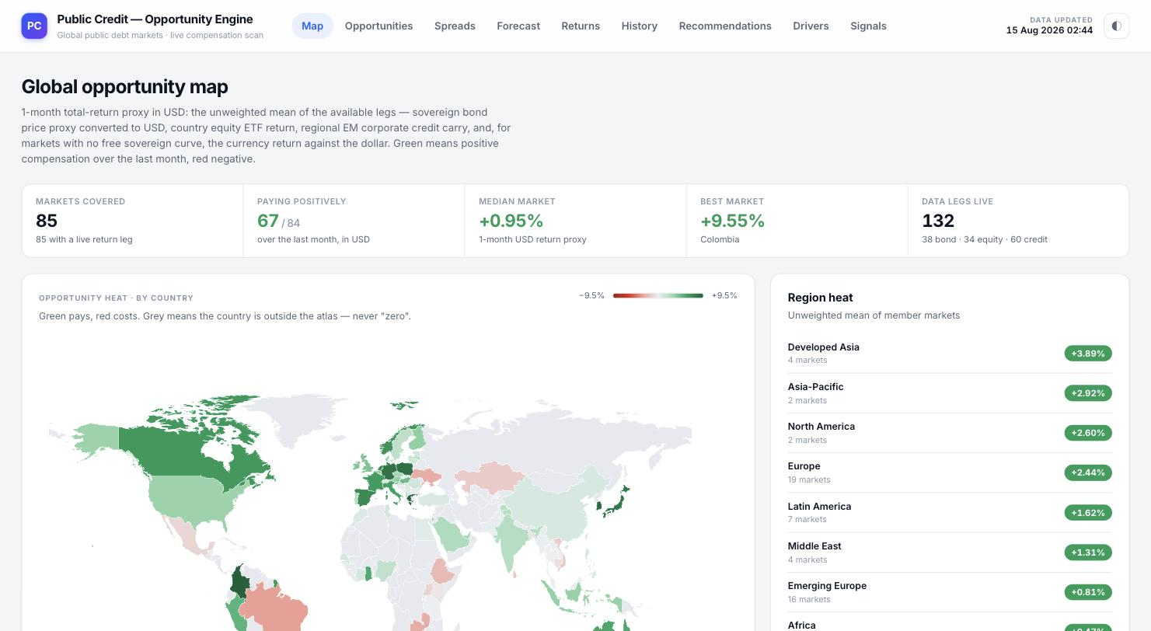
The Map page on load: description, the five coverage cards, the world choropleth and the start of the Region heat list.

What the heat measures
The page states its own definition at the top: a one-month total-return proxy in US dollars, built as the unweighted mean of whichever of these legs exist for a given country — the sovereign bond price proxy (converted to USD), the country's equity ETF return, a regional emerging-market corporate credit carry figure, and, for a country with no free sovereign yield curve, the currency's return against the dollar instead. Green on the map means that blend was positive over the last month; red means it was negative; grey means the country is simply outside the atlas's coverage — the page is explicit that grey is a coverage gap, never a hidden zero.

The five coverage cards
— Markets Covered — the count of countries with at least one live return leg (85 at the time of these screenshots).
— Paying Positively — how many of those markets showed a positive one-month USD return, as a fraction of the total (67 of 84).
— Median Market — the median one-month USD return proxy across all covered markets, a single-number read on whether the world is broadly paying more or less than usual right now.
— Best Market — the single highest-paying market over the last month and its return, named directly on the card (Colombia, +9.55% in these screenshots).
— Data Legs Live — the total count of individual data series feeding the whole map, broken into bond, equity and credit legs, so the reader can see how much of the picture rests on which kind of source.

The map and the Region heat panel
The choropleth itself is labelled Opportunity heat · by country, with a colour legend running from −9.5% (deep red) to +9.5% (deep green) and the reminder that grey territory is outside the atlas. Hovering or clicking a shaded country opens its dedicated drill-down page, covered below. To its right, the Region heat panel lists every macro-region — Developed Asia, Asia-Pacific, North America, Europe, Latin America, Middle East, Emerging Europe, Africa, Emerging Asia, Southeast Asia — each tagged with how many markets it contains and its own unweighted mean return, letting the reader see at a glance which part of the world is currently paying the most without scanning the map pixel by pixel.
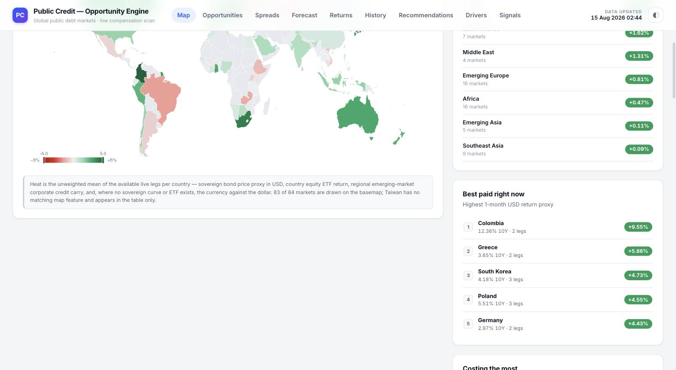
Scrolled further down: the rest of the Region heat list, the map's own explanatory note, and the Best paid right now leaderboard.

Best paid right now / Costing the most
Below the map and region list, two ranked leaderboards single out individual countries rather than regions. Best paid right now lists the five highest one-month USD return proxies — in these screenshots led by Colombia at +9.55% (12.36% ten-year yield, built from two live legs), followed by Greece, South Korea, Poland and Germany — each row showing the country's headline 10-year yield alongside the return figure and how many data legs support it. A mirror-image Costing the most list (immediately below, off the visible crop) ranks the worst-paying markets the same way. Both lists are read-only shortcuts into the same country pages the map itself links to.

The country drill-down page
Clicking any country — on the map, in the region list or in either leaderboard — opens a dedicated page for that market, reachable by a Back to the map link at the top. The header restates the country name, its two-letter code, its region tag, and its overall heat figure and horizon (for example +4.43% · 1M USD), together with a one-line statement of exactly how many live legs were averaged to produce that number and which ones they were.
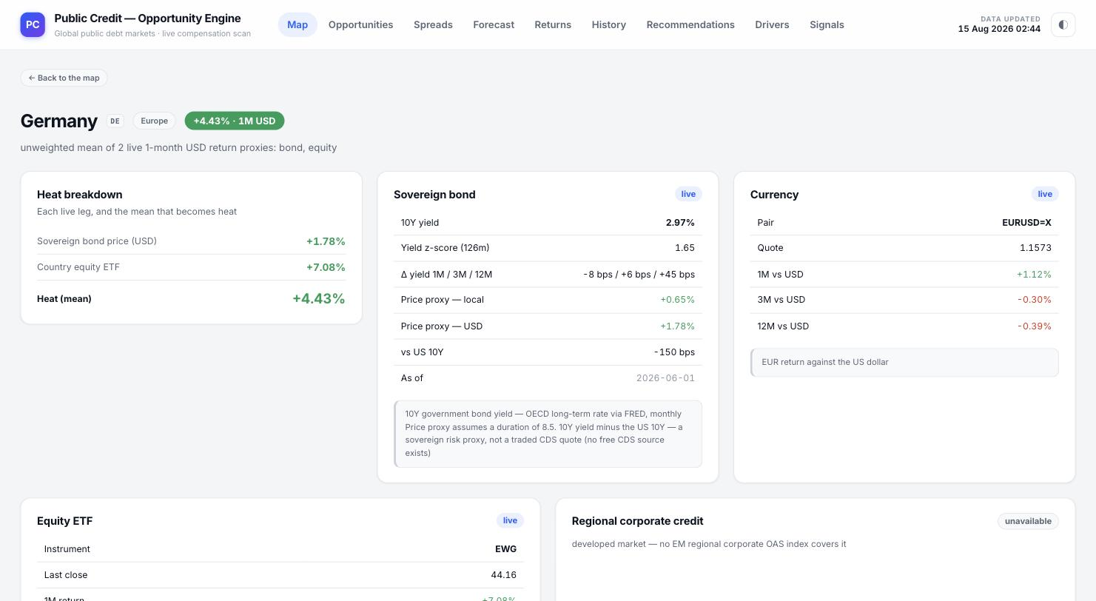
The Germany drill-down page: heat breakdown, sovereign bond detail, currency detail, and the start of the equity ETF and regional-credit cards.
Beneath the header, up to five cards break the heat figure down into its parts:
— Heat breakdown — lists each live leg (for Germany, Sovereign bond price in USD and Country equity ETF) with its own one-month return, and the mean of those legs that is the country's overall heat figure.
— Sovereign bond — the live 10-year yield, its z-score against 126 months of its own history, the change over the last 1, 3 and 12 months in basis points, the bond's price-return proxy in both local currency and USD terms, the spread of this yield against the US 10-year in basis points, and the as-of date of the underlying observation, together with a note explaining that the price proxy assumes a duration of 8.5 years and that the versus-US-10Y figure is a yield-differential proxy, not a traded CDS quote.
— Currency — the FX pair being used (for Germany, EURUSD), its current quote, and the currency's own return against the US dollar over 1, 3 and 12 months, with a one-line reminder of exactly what direction is being measured.
— Equity ETF — the specific listed fund used as the country's equity proxy (for Germany, EWG), its last close price, and its trailing one-month return.
— Regional corporate credit — where a regional EM corporate credit index actually applies to that country it is shown here; where it does not (Germany, a developed market with no EM regional OAS index covering it), the card says so explicitly, tagged unavailable, rather than being left off the page or silently substituted.

3. The Opportunity Board
Where the Map answers "which country is paying the most," the Opportunities page answers a narrower and sharper question for two separate universes — corporate credit indices and sovereign yield curves — "is this specific instrument paying more or less than it usually does?" It is the platform's main relative-value screen.
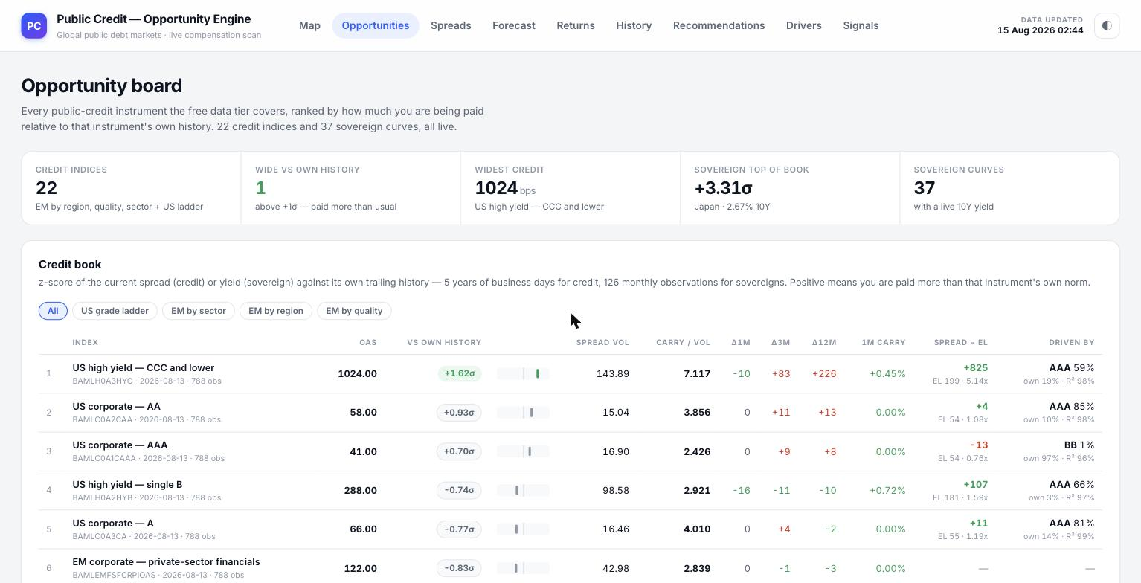
The Opportunities page on load: description, the five credit-side coverage cards, and the start of the Credit book table.

The credit-side coverage cards
— Credit Indices — the count of corporate credit indices covered (22: the full US investment-grade/high-yield ladder plus EM indices split by region, sector and quality).
— Wide vs Own History — how many of those indices currently sit more than one standard deviation above their own historical norm, i.e. are paying unusually generously right now (1 in these screenshots).
— Widest Credit — the single widest spread on the board in basis points, and which index it belongs to (1024 bps, US high yield CCC and lower).
— Sovereign Top of Book — the single most-stretched sovereign yield versus its own history, in standard deviations, and which country (+3.31σ, Japan at 2.67% ten-year).
— Sovereign Curves — the count of government 10-year curves covered with a live yield (37).

The Credit book table
The table is explicit about what its central column means: a z-score of the current spread against that instrument's own trailing history — five years of daily business-day observations for credit indices. Positive means the market is paying more than that index's own norm; negative means less. Five filter chips along the top (All, US grade ladder, EM by sector, EM by region, EM by quality) narrow the table to a specific slice of the credit universe without leaving the page.
Each row carries: the index name, its underlying ticker and how many observations back its history (for example BAMLH0A3HYC, 788 obs); OAS, the option-adjusted spread in basis points; VS OWN HISTORY, the z-score described above shown as a coloured badge next to a small histogram sparkline of where that value sits within its own distribution; SPREAD VOL, the annualised volatility of the spread itself; CARRY / VOL, the spread divided by that volatility — compensation per unit of the risk that the spread could move against the holder; Δ1M / Δ3M / Δ12M, the spread's change in basis points over those three windows; 1M CARRY, the trailing one-month mark-to-market return proxy built from the spread's own recent move; SPREAD − EL, net compensation after subtracting a modelled expected loss (with the expected loss and a cover ratio shown underneath); and DRIVEN BY, the single credit index shown by the Drivers page (Section 8) to explain the most of this index's own forecast uncertainty, together with that driver's share and the model's R².
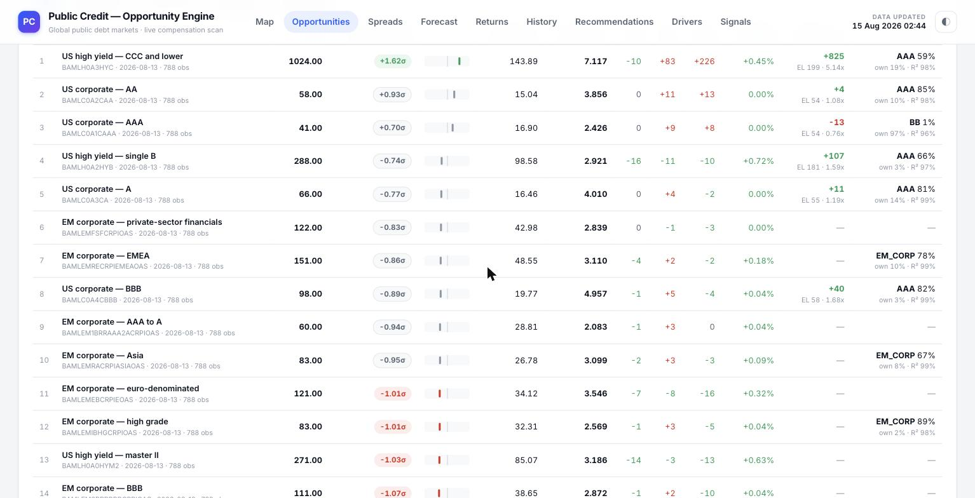
The Credit book scrolled further down the US grade ladder and into the EM corporate universe.
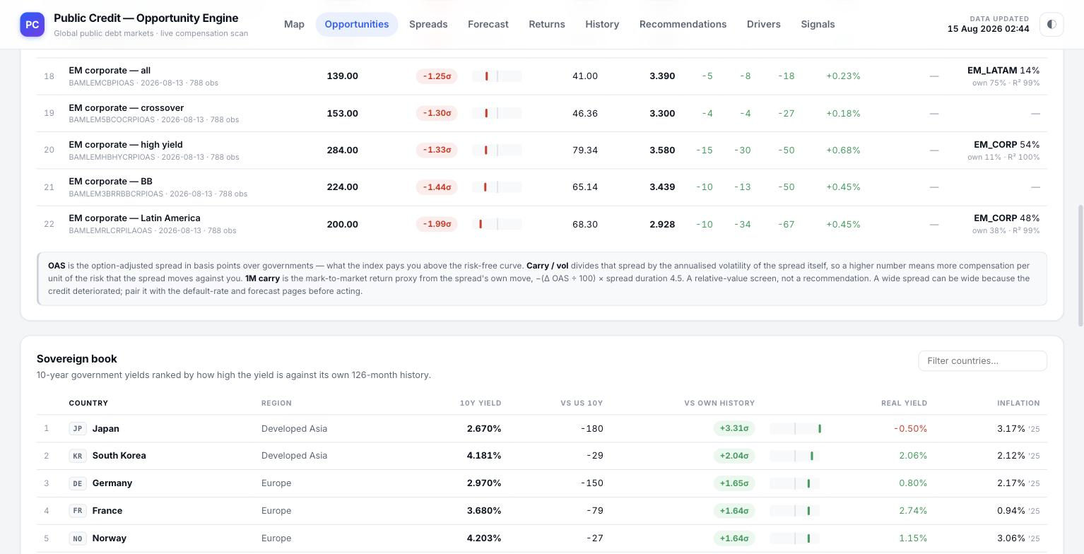
The Credit book's own footnote, and the header row of the Sovereign book immediately below it.
A footnote directly under the credit table restates the three technical terms in plain language — OAS is the spread over the government curve; carry / vol divides that spread by its own volatility; 1M carry is the mark-to-market return proxy from the spread's recent move — and adds an explicit caution: this is a relative-value screen, not a recommendation, and a wide spread can be wide because the credit genuinely deteriorated, so it should be paired with the default-rate and forecast pages before acting on it.

The Sovereign book table
Below the credit table, the Sovereign book ranks all 37 covered government yield curves by how stretched each one is against its own history, with a text box to filter the list by country name. Each row shows: COUNTRY (with its two-letter code and flag chip) and REGION; 10Y YIELD, the current headline government bond yield; VS US 10Y, the spread of that yield against the US ten-year in basis points; VS OWN HISTORY, the same kind of z-score badge and sparkline used on the credit side, but built from 126 months of that country's own yield history; REAL YIELD, the nominal yield less the latest published consumer-price inflation figure; and an INFLATION column carrying the inflation print itself together with the year it was published.
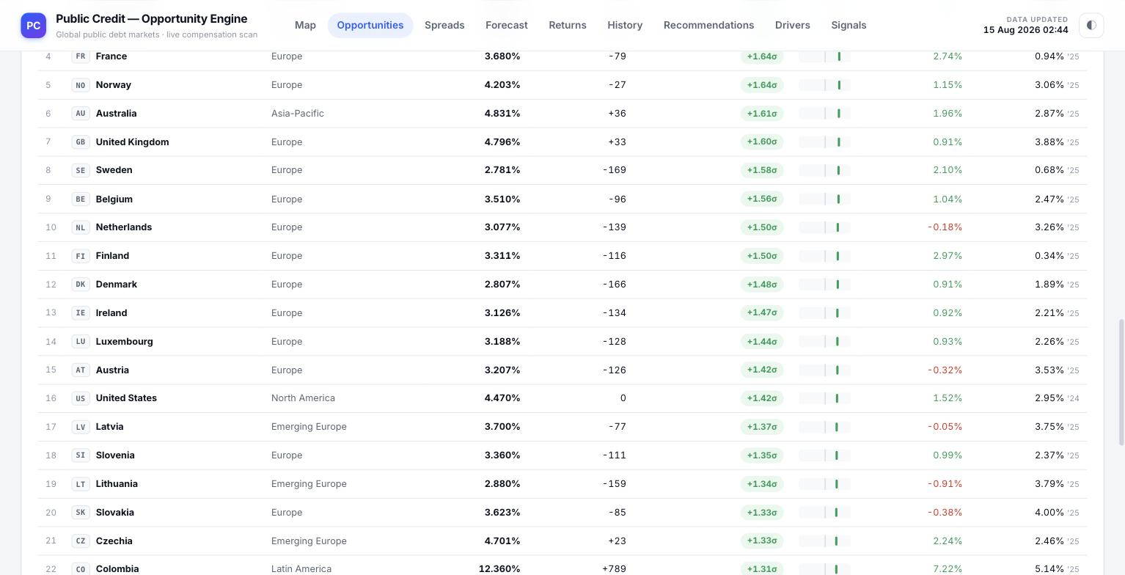
The Sovereign book continuing through the middle of the ranked list.
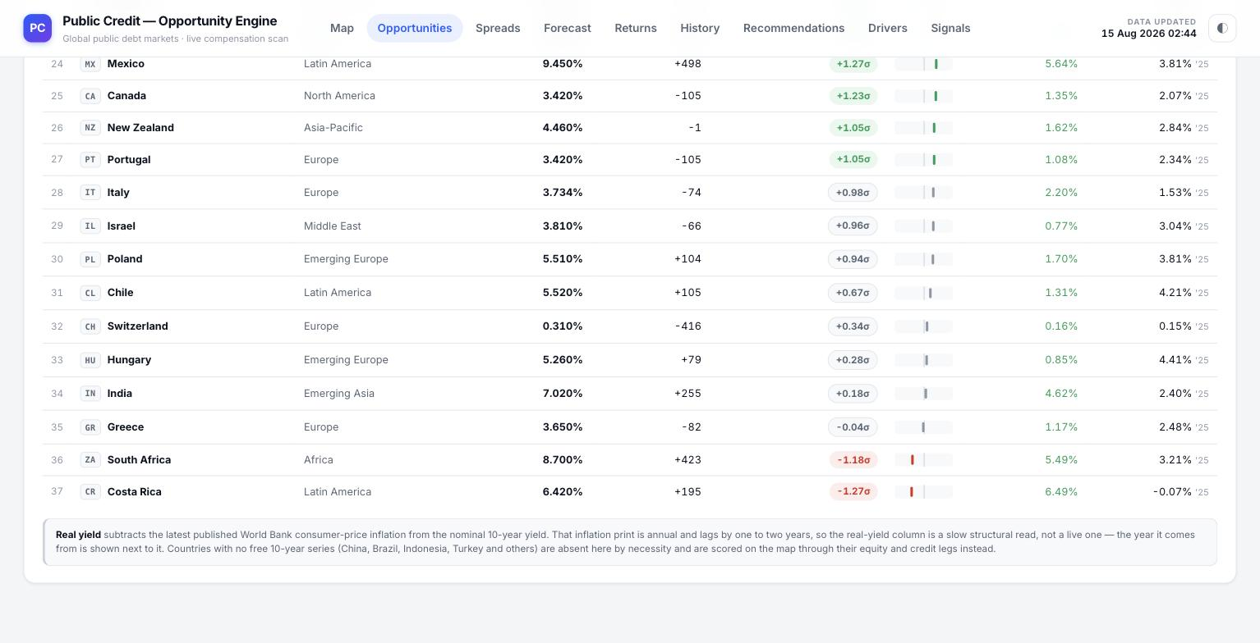
The bottom of the Sovereign book and its explanatory note on the real-yield construction and coverage gaps.
A footnote under the sovereign table explains the real-yield construction carefully: because the inflation print is annual and lags by one to two years, the real-yield column is a slow structural read rather than a live one, and the exact year that inflation figure was published is shown alongside it so the reader knows how stale that half of the calculation is. It also names the handful of major economies with no free ten-year series (China, Brazil, Indonesia, Turkey and others), explaining that they are absent from this table by necessity and are instead scored on the Map page through their equity and credit legs only.

4. Spread Minus Expected Loss
The Spreads page takes the US corporate credit ladder — the seven standard rating rungs from AAA down to CCC and below — and asks a single question of each rung: after paying for the losses a holder should statistically expect, is the market still compensating for the risk, and by how much? It deliberately excludes every cost specific to trading volatility (dealer markup, straddle premium, execution friction); those belong to the Returns page's volatility-strategy view, not here.
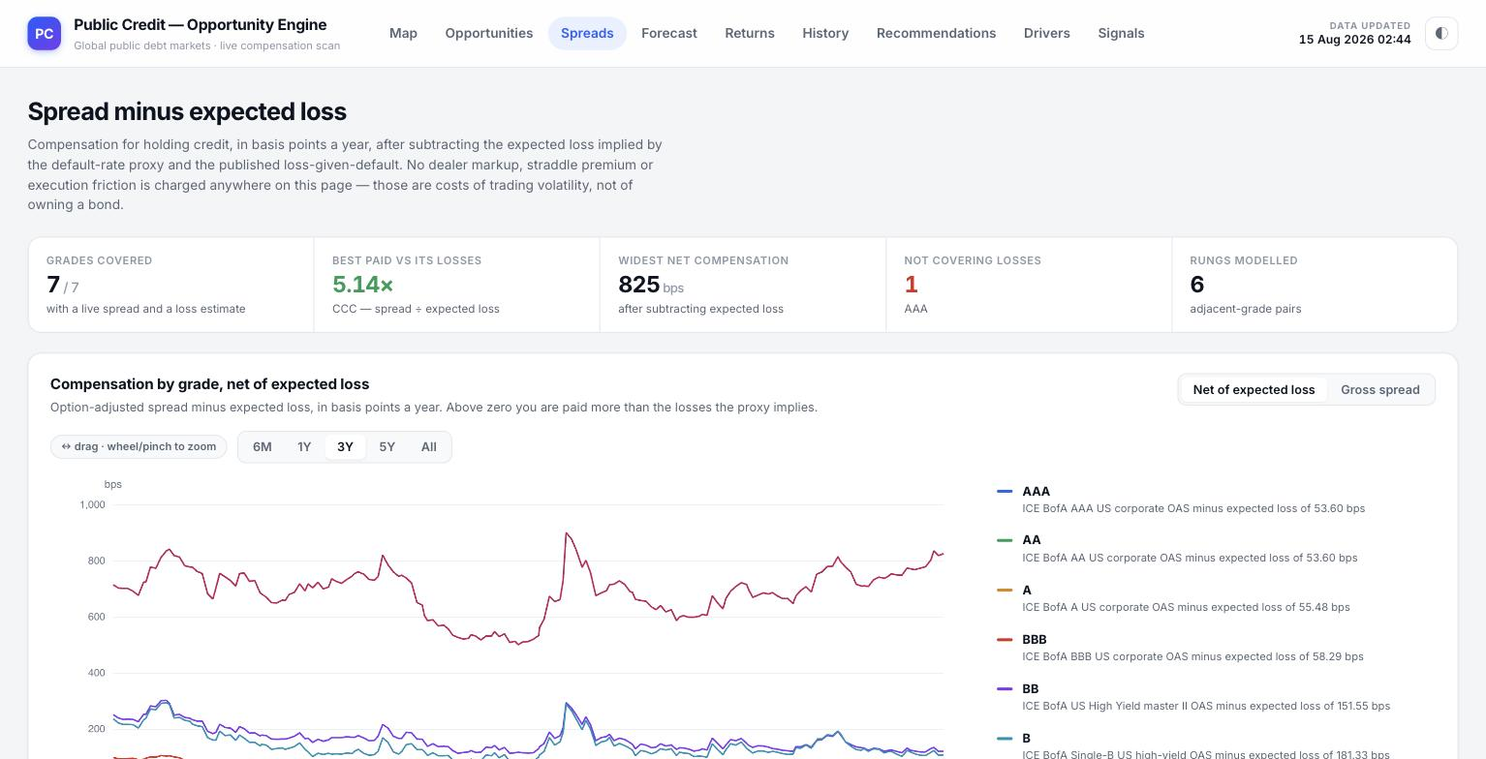
The Spreads page on load: description, the five coverage cards, and the start of the grade-by-grade chart.

The coverage cards
— Grades Covered — how many of the seven standard rungs have both a live spread and a loss estimate (7 of 7).
— Best Paid vs Its Losses — the highest cover ratio on the ladder, i.e. the rung whose spread most exceeds its own modelled expected loss (5.14×, CCC and lower in these screenshots).
— Widest Net Compensation — the largest spread-minus-expected-loss figure on the ladder, in basis points (825 bps, again CCC and lower).
— Not Covering Losses — how many rungs currently have a spread narrower than their own modelled expected loss, meaning the market is arguably not paying enough for the risk (1, AAA in these screenshots).
— Rungs Modelled — the count of adjacent-grade pairs the ladder is broken into for the contagion work on the Forecast page (6).

The grade-by-grade chart
The main chart plots Compensation by grade, net of expected loss, for each of the seven rungs (AAA, AA, A, BBB, BB, B, CCC) over a chosen time window, using the same draggable zoom and preset range buttons (6M / 1Y / 3Y / 5Y / All) used throughout the platform. A toggle in the top-right switches the whole chart between Net of expected loss (the default) and Gross spread, so the reader can see how much of the visible spread is actually explained away by expected credit losses versus how much is left over as pure compensation. The legend on the right names each line and restates, per grade, the exact expected-loss figure that was subtracted from its gross spread to build the line.
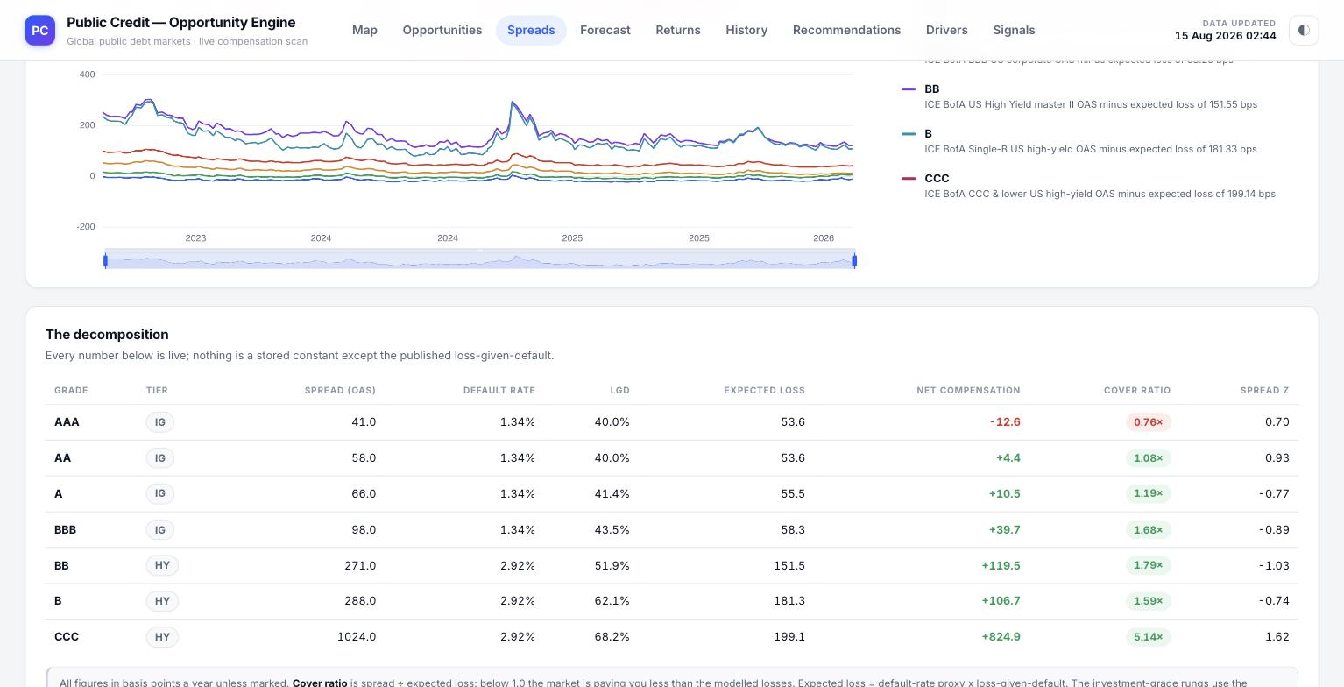
Scrolled down: the tail of the chart's legend and the full seven-row decomposition table beneath it.

The decomposition table
Below the chart, The decomposition breaks every rung down into the exact inputs used to build the net-compensation figure, stating plainly that every column is live except the published loss-given-default constant: GRADE and TIER (investment-grade or high-yield); SPREAD (OAS), the raw option-adjusted spread; DEFAULT RATE, the modelled annual default-rate proxy for that rung; LGD, loss given default, the fraction of exposure not recovered if a default occurs; EXPECTED LOSS, the product of the default rate and LGD, expressed in basis points; NET COMPENSATION, the spread less that expected loss (shown in green when positive, red when negative); COVER RATIO, the spread divided by the expected loss — how many times over the spread compensates for the modelled loss; and SPREAD Z, the same kind of own-history z-score used elsewhere on the platform. A closing note underneath spells out the cover-ratio threshold explicitly: below 1.0, the market is paying less than the modelled losses, and the investment-grade rungs use one shared default-rate proxy while the high-yield rungs use another, reflecting how those default probabilities are actually estimated.

5. VAR Forecast & Contagion
The Forecast page is where the platform stops describing the present and starts projecting forward. It fits a statistical model — a vector autoregression, VAR — to the six adjacent-grade spread-minus-expected-loss pairs from the Spreads page, and uses that fitted model both to project each pair twelve business days ahead and to show how a shock to any one rung of the credit ladder would be expected to spread to the others.
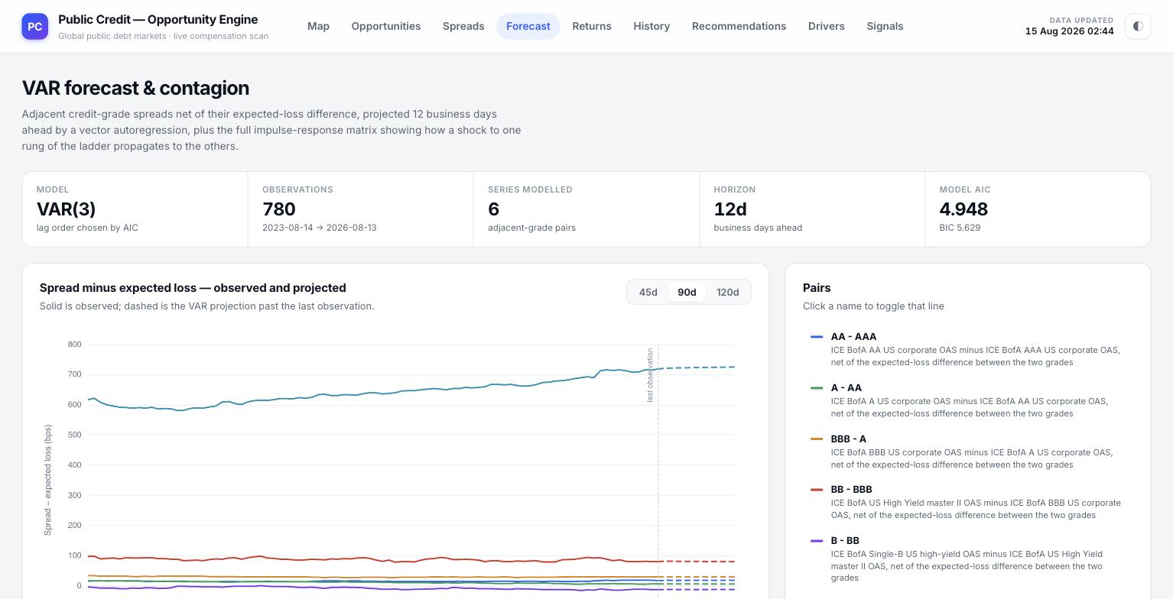
The Forecast page on load: description, the five model-diagnostic cards, and the start of the projected-versus-observed chart.

The model-diagnostic cards
— Model — the exact model fitted and its lag order, stated plainly (VAR(3) in these screenshots — the model looks back three periods).
— Observations — how many daily observations the model was fitted on (780, spanning the dated window shown underneath).
— Series Modelled — how many adjacent-grade pairs feed the system (6).
— Horizon — how many business days ahead the projection runs (12d).
— Model AIC — the Akaike information criterion the lag order was chosen by, with the BIC alternative given alongside it, so a reader who understands model selection can see the fit was not simply eyeballed.

The projected-versus-observed chart
The chart title, Spread minus expected loss — observed and projected, is followed by the single most important instruction on the page: solid is observed, dashed is the VAR projection past the last observation. A vertical marker labelled last observation sits exactly where history ends and the model's own projection begins. Six lines are plotted, one per adjacent-grade pair (AA−AAA, A−AA, BBB−A, BB−BBB, B−BB, CCC−B); a Pairs legend on the right names each line, restates in words exactly what it measures, and lets the reader click any name to toggle that single line on or off. The usual 45d / 90d / 120d range buttons and drag-to-zoom strip control how much of the observed history is shown alongside the projection.
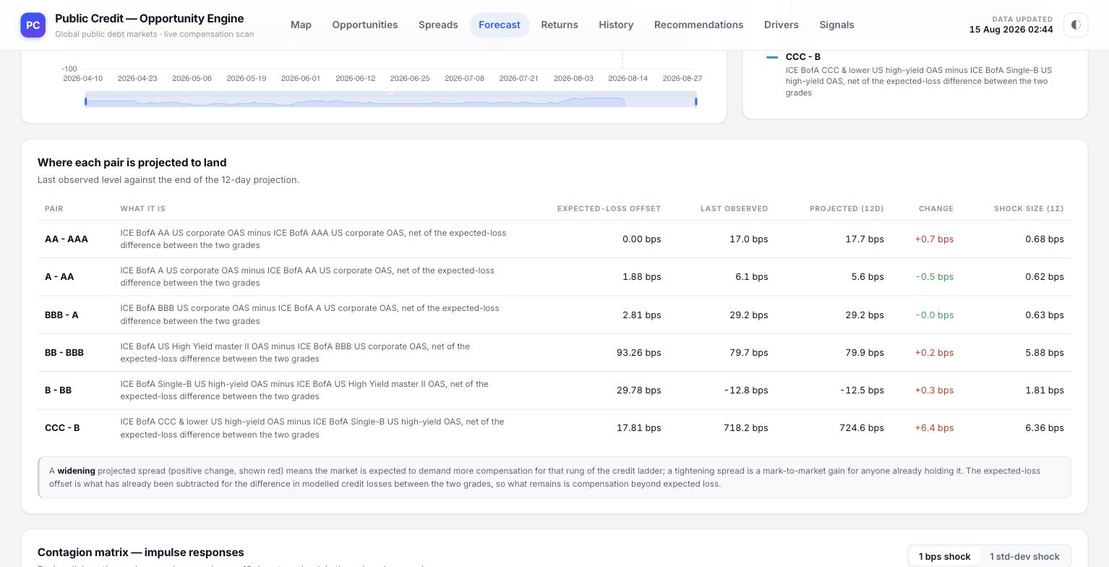
Scrolled down: the full pairs legend, the six-row projection table, and the explanatory note beneath it.

"Where each pair is projected to land" table
This table turns the dashed lines on the chart into exact numbers: PAIR and WHAT IT IS (a plain-language restatement of the two grades being differenced); EXPECTED-LOSS OFFSET, the modelled difference in expected loss between the two grades that has already been netted out; LAST OBSERVED, the pair's most recent real value; PROJECTED (12D), where the model expects it to sit twelve business days later; CHANGE, the difference between those two figures, coloured red for a widening spread and green for a tightening one; and SHOCK SIZE (1σ), the pair's own one-standard-deviation move, given as a scale reference for how large the projected change actually is in context. The note directly beneath states the reading rule explicitly: a widening projected spread means the market is expected to demand more compensation for that rung of the ladder, while a tightening one is a mark-to-market gain for anyone already holding it.
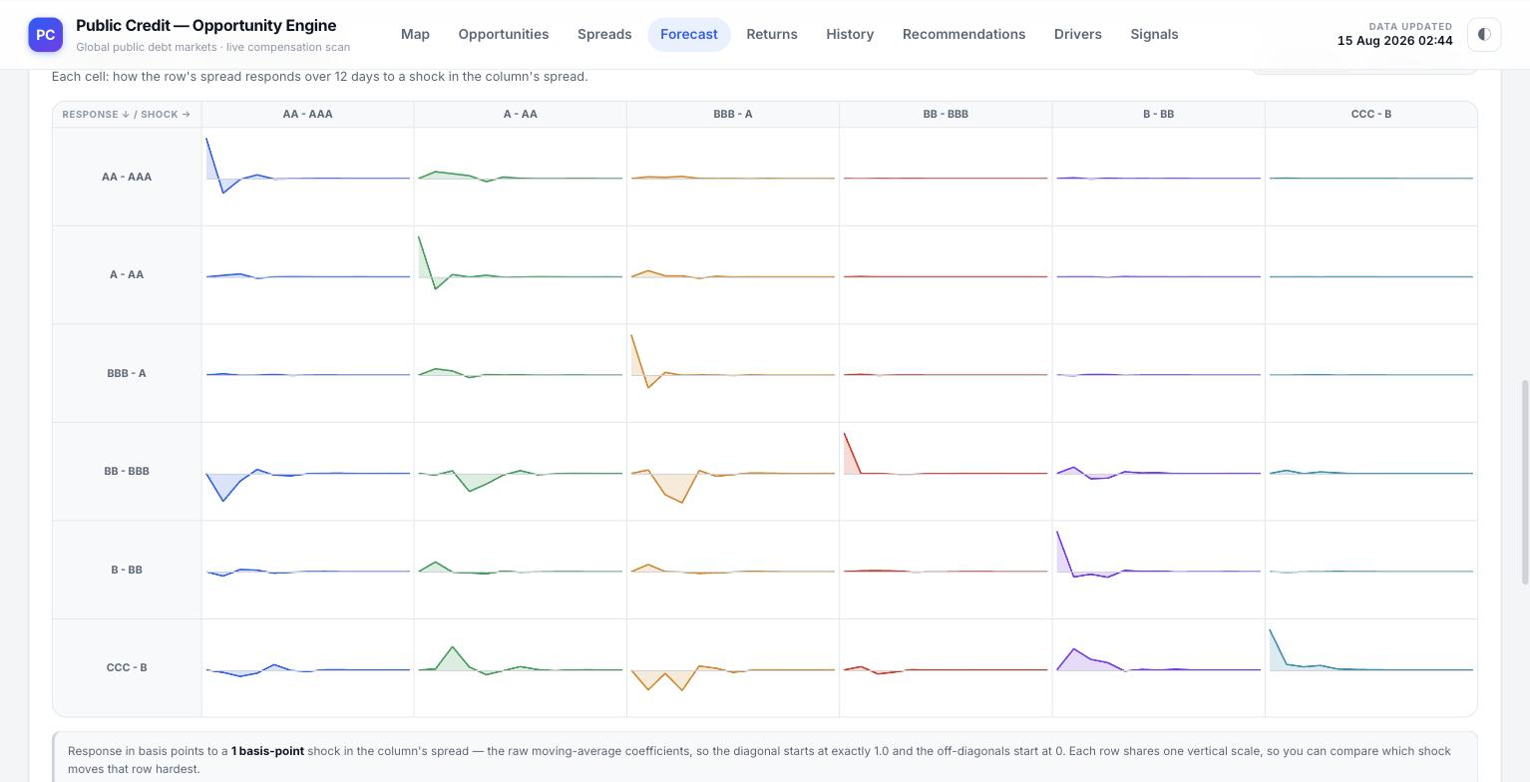
The contagion matrix: each small chart shows how one pair's spread is expected to respond, over twelve days, to a shock in another.

The contagion matrix
Titled Contagion matrix — impulse responses, this is a six-by-six grid of small charts. Each cell answers one specific question: how does the row's spread respond over the twelve-day horizon to a shock in the column's spread? The diagonal cells (row equals column) show a pair's response to a shock in itself, which necessarily starts at its full size and decays; off-diagonal cells show genuine contagion — how a shock somewhere else in the credit ladder is expected to bleed into a different rung. A toggle in the top-right switches the shock size the whole grid is built from between a uniform 1 bps shock and a 1 standard-deviation shock scaled to each pair's own historical volatility, and every row shares one vertical scale so the reader can compare, within a row, which column's shock moves that pair the hardest.
A detailed technical note beneath the grid documents exactly how the model works, in the platform's own words: a vector autoregression is fitted per panel, every series regressed on the recent history of every series including itself; shocks are orthogonalised by a Cholesky decomposition in a stated order (AAA→AA→A→BBB→BB→B→CCC), which assumes an earlier series in that order can move a later one within the same period but not the reverse, and the note is explicit that the decomposition would change if that ordering changed. It also restates the spectral radius of the fitted system and what it means for whether shocks are expected to decay or persist.

6. Returns — Buy-and-Hold and Volatility Strategy
The Returns page simulates forward, rather than just projecting a single path, and does it for two entirely different ways of holding a position: owning the instrument outright (Buy & hold) or trading its volatility through an at-the-money straddle (Volatility strategy). A pair of top-level tabs switches between the two; everything below them changes to match.

Buy-and-hold
With Buy & hold selected, the page states its own definition plainly: carry accrued while you own the asset, marked to a VAR forecast of the spread or yield, with the note that where the forecast level rises by more than the carry pays, the line turns over — meaning the position's cumulative return can start falling even though carry is still being earned, because the mark-to-market loss on the level move outweighs it, and that turning point is marked directly on the chart.
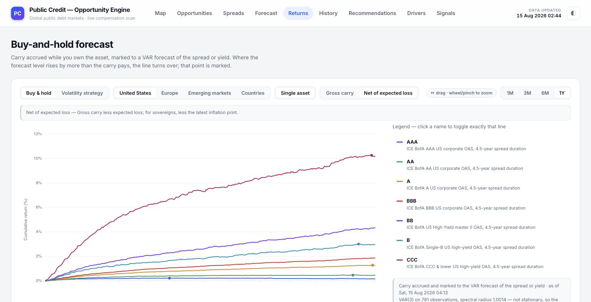
The Returns page in Buy & hold mode: mode and universe toggles, and the projected cumulative-return chart for the US credit ladder.
A row of controls sits above the chart: the Buy & hold / Volatility strategy mode switch itself; a set of universe tabs (United States, Europe, Emerging markets, Countries) choosing which instrument family is charted; a Single asset / (relative-value, where applicable) toggle; a Gross carry / Net of expected loss switch, mirroring the same choice offered on the Spreads page; the usual drag-to-zoom strip; and 1M / 3M / 6M / 1Y range buttons. The chart itself plots cumulative return in percent for each of the seven US grade lines from AAA to CCC, with a legend on the right naming each line and its underlying index.
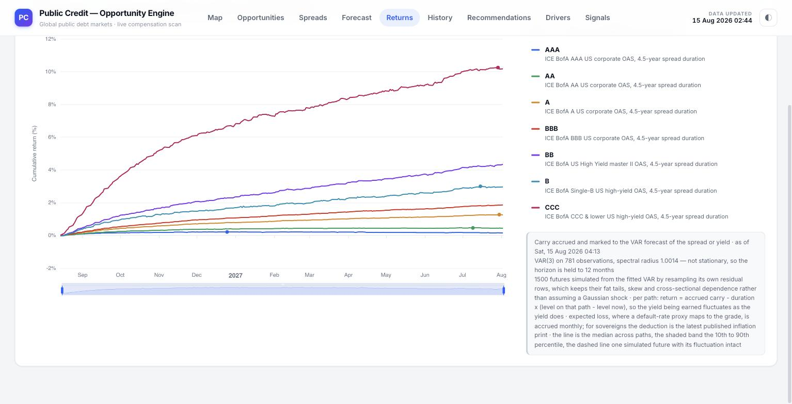
The full-width chart and the methodology note describing exactly how the simulated paths were built.
A note box beneath the chart documents the simulation in the platform's own words: carry is accrued and marked to the VAR forecast of the spread or yield as of a stated timestamp; because the fitted model's spectral radius sits fractionally above 1.0 (not stationary), the projection horizon is deliberately held to twelve months rather than extrapolated indefinitely; 1,500 individual future paths are simulated by resampling the model's own fitted residuals — preserving whatever fat tails, skew and cross-series dependence the real data actually showed, rather than assuming a clean bell-curve shock; each path's return is built from carry accrued minus a duration-scaled price effect, and, for credit, an expected-loss deduction accrued monthly is layered in on top. The plotted line is the median outcome across all 1,500 paths, the shaded band spans the 10th to 90th percentile of those paths, and a single dashed line traces one specific simulated future so the reader can see what one plausible, un-smoothed path actually looks like rather than only the averaged view.

Volatility strategy
Switching the top toggle to Volatility strategy reframes the same instruments as an options trade: one at-the-money straddle, opened today and marked to market each month until it expires, rather than a new trade being opened at every horizon. The description on the page states the payoff logic directly — value comes from the underlying drifting away from the strike; working against it are time decay, the dealer's premium, and financing on that premium. A Single asset / Relative value toggle lets the reader price a straddle on one series alone or on the spread between two series (for example the same adjacent-grade pairs used on the Forecast page).
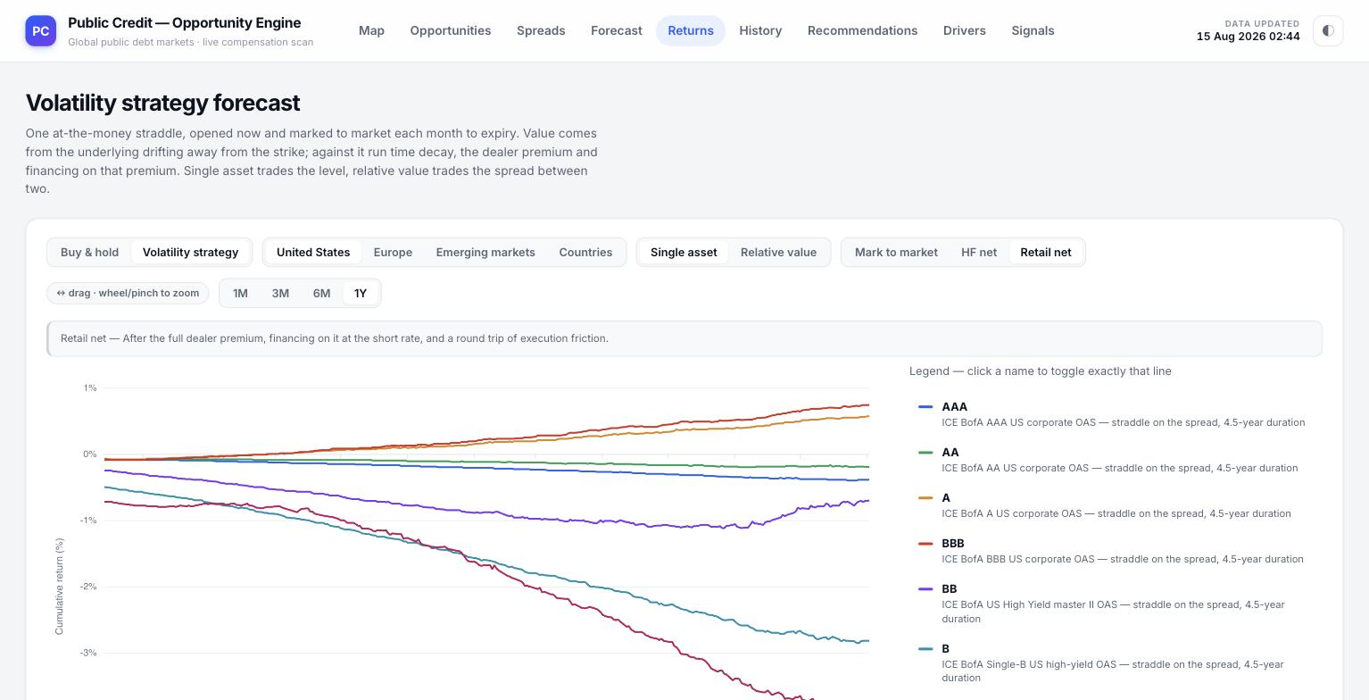
The Returns page switched to Volatility strategy mode, showing the retail-net cumulative return for a straddle on each grade.
A second row of toggles — Mark to market, HF net and Retail net — controls exactly which costs are charged against the raw straddle value. Mark to market shows the option's theoretical value alone; HF net subtracts an institutional-scale dealer premium and financing cost; Retail net, shown selected in these screenshots, subtracts the full retail-scale dealer premium, financing on that premium at the short rate, and a round trip of execution friction, giving the most conservative, most realistic view of what an actual retail position would net. This is precisely the layer of cost that earlier iterations of this page omitted, and it is why straddle returns here look meaningfully worse, and far more differentiated across grades, than a textbook option-pricing formula alone would suggest.
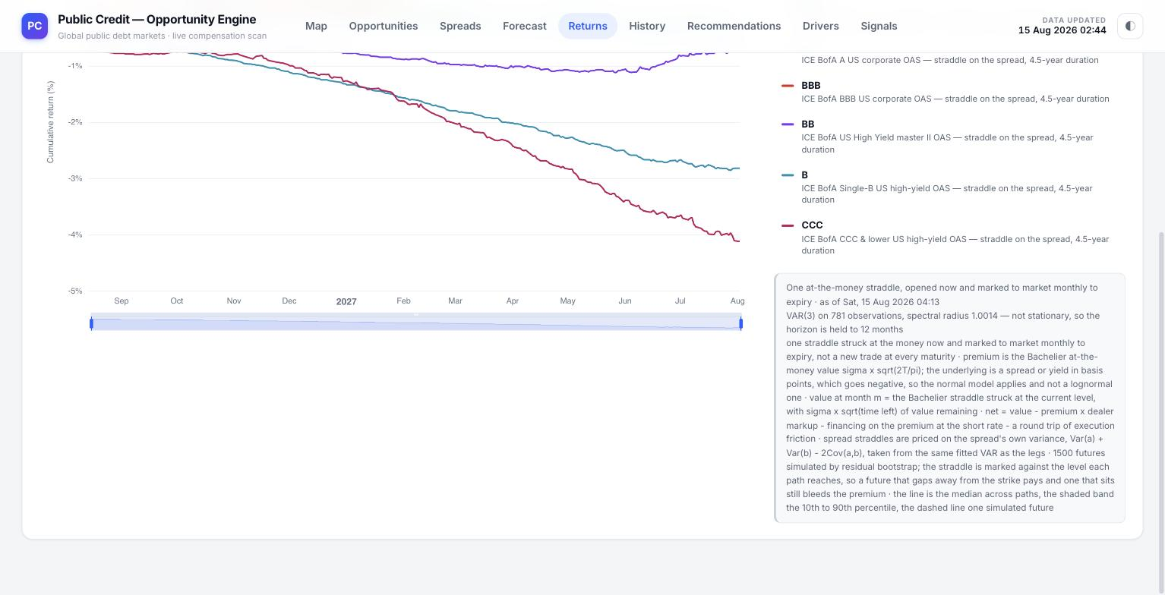
The volatility-strategy chart continuing down through its most negative grade lines, and the methodology note explaining the option-pricing construction.
The methodology note under the volatility-strategy chart is equally explicit: the straddle is priced with the Bachelier at-the-money formula, appropriate because the underlying (a credit spread or a government yield) can go negative, which rules out the lognormal Black-Scholes model; a spread straddle (the relative-value case) is priced on the spread's own variance, computed from the two legs' individual variances and their covariance, all taken from the same fitted VAR system used elsewhere on the platform; the same 1,500-path residual-bootstrap simulation used on the buy-and-hold side is reused here, with the straddle marked against the level each simulated path actually reaches — so a path that gaps away from the strike pays off, and a path that sits still simply bleeds premium every month, exactly as a real straddle would.

7. Actual History
The History page is the platform's plain data-room: no forecasting, no simulation, no derived compensation metric — just the real, observed series everything else on the platform is built from, so a reader can check the raw inputs for themselves.
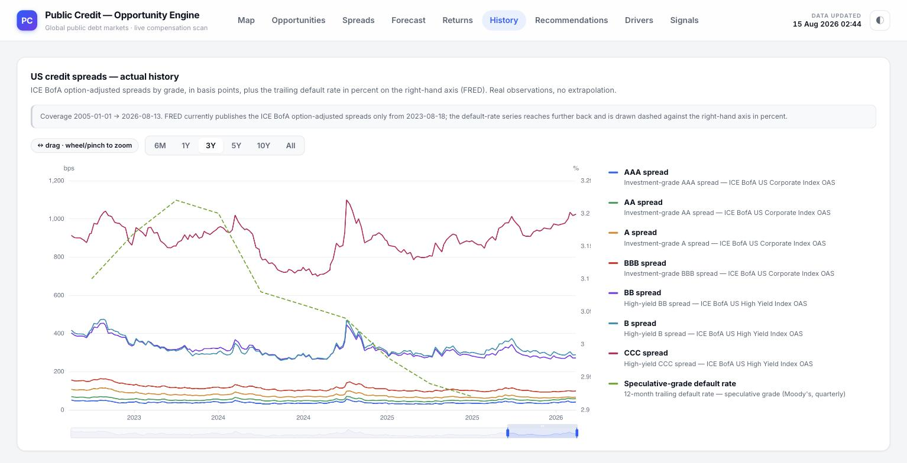
US credit spreads — actual history: all seven grade spreads plotted together with the trailing speculative-grade default rate on the right-hand axis.

US credit spreads — actual history
The top panel plots all seven ICE BofA option-adjusted spread series (AAA through CCC and below) on the left-hand axis, in basis points, and overlays the trailing twelve-month speculative-grade default rate (sourced from Moody's via FRED, drawn dashed) on a separate right-hand percentage axis, so the reader can visually compare how spreads have moved against the actual realised default backdrop over the same period. A coverage note above the chart is specific about a real data-vintage limit: FRED currently publishes the ICE BofA option-adjusted spreads only from a certain date forward, while the default-rate series reaches further back, and both facts are stated rather than smoothed over. The usual drag-to-zoom strip and 6M / 1Y / 3Y / 5Y / 10Y / All range buttons sit above the chart; the legend on the right names every line with its precise index description.
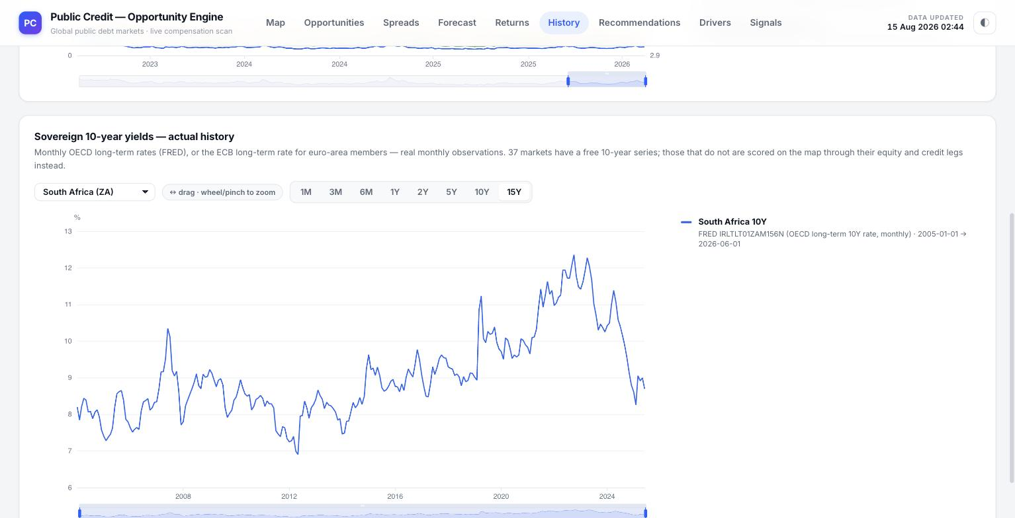
Sovereign 10-year yields — actual history, here showing South Africa's benchmark government yield over a 15-year window.

Sovereign 10-year yields — actual history
The second panel is a single-country chart: a dropdown selector (South Africa is shown in this example) lets the reader pick any of the covered sovereigns, and the chart plots that country's monthly 10-year government bond yield over the selected window, again with the drag-to-zoom strip and a full set of range buttons from 1M out to 15Y. The page states its sourcing precisely — OECD long-term rates via FRED for most countries, or the ECB's own long-term rate series for euro-area members — and repeats the same coverage caveat used on the Opportunities page: 37 markets carry a free ten-year series; the countries that do not are scored elsewhere, on the Map, through their equity and credit legs instead.

8. Model Drivers
The Drivers page answers a question the Forecast page's contagion matrix raises but does not summarise on its own: of everything a statistical model cannot predict about one series, how much of that uncertainty traces back to shocks in the other series around it, rather than to the series' own unpredictable moves? The page states its method and its honesty commitment together, up front: a vector autoregression is fitted to each panel, every series regressed on the recent history of every series including itself, and no neural network is involved — every number traces to an estimated coefficient.
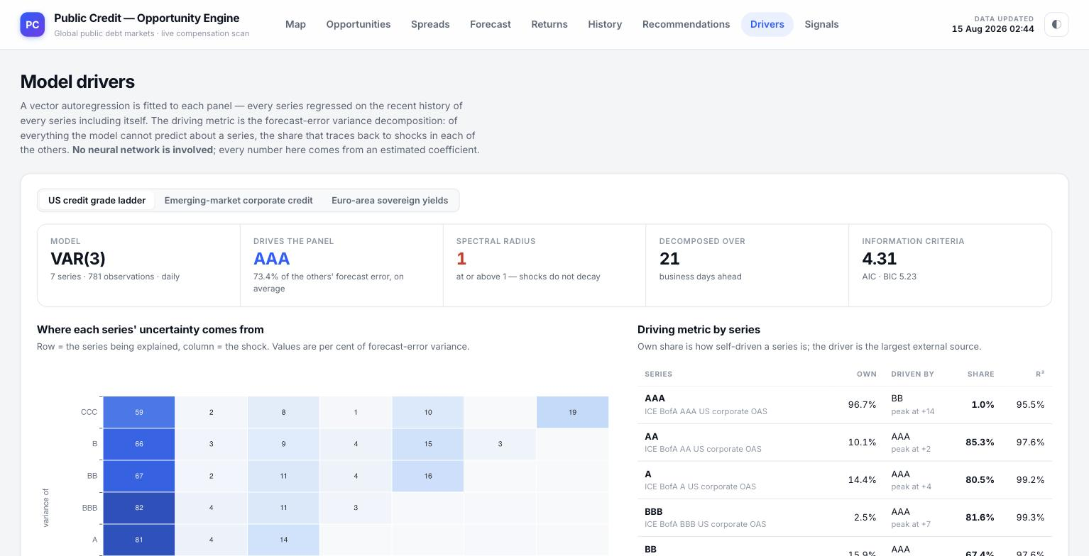
The Drivers page on load: the three panel tabs, the five model-diagnostic cards, and the start of the variance-decomposition heatmap.

The three panels
Three tabs — US credit grade ladder, Emerging-market corporate credit, Euro-area sovereign yields — switch the whole page between three independently fitted systems, because pooling unrelated instrument groups into one model would blur exactly the kind of cross-series relationship this page exists to show.

The model-diagnostic cards
— Model — the fitted specification and lag order (VAR(3) in these screenshots), together with how many series and observations went into it.
— Drives the Panel — the single series shown to explain the largest average share of every other series' forecast uncertainty (AAA, at 73.4% of the others' forecast error on average, in these screenshots) — the panel's dominant node.
— Spectral Radius — the largest eigenvalue of the fitted system; at or above 1 means shocks in the model do not decay over time, a genuine statistical property of the fitted data that the page reports rather than hides.
— Decomposed Over — the forecast horizon, in business days, that the variance decomposition below is measured at (21).
— Information Criteria — the AIC and BIC the lag order was chosen by.

"Where each series' uncertainty comes from" — the heatmap
Titled with exactly that question, the heatmap has one row and one column per series in the panel; a cell at row i, column j shows what percentage of series i's forecast-error variance traces back to shocks originating in series j, so reading straight down the diagonal shows how self-driven each series is on its own. Darker shading marks a larger share. In the US ladder shown in these screenshots, the diagonal cells are large (AAA explains 97% of its own uncertainty; CCC only 59% of its own), which itself is informative: the most speculative grade is the one most exposed to shocks originating elsewhere in the ladder, not to its own idiosyncratic moves.
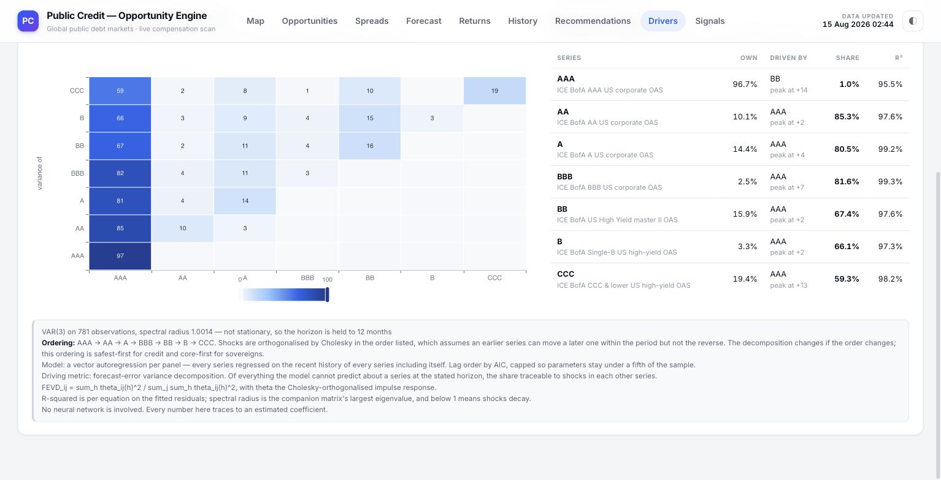
The full heatmap, the Driving metric by series table, and the detailed technical note documenting exactly how the decomposition is built.

"Driving metric by series" table
The table alongside the heatmap turns each row of it into a plain sentence: SERIES, the instrument being explained; OWN, what share of its own forecast uncertainty is self-driven; DRIVEN BY, the single external series that explains the largest share of what is left, together with the horizon (in business days) at which that external influence peaks; SHARE, that external driver's own percentage contribution; and R², the fitted equation's own goodness of fit for that series. This is the same DRIVEN BY figure that appears attached to every row of the Credit book table on the Opportunities page — this page is where that figure is actually computed and explained in full.
A closing technical note documents, in the platform's own words, the exact ordering assumption behind the Cholesky orthogonalisation used to attribute variance shares, the formula used for the decomposition itself, and the precise definitions of R² and spectral radius used elsewhere on the page — repeating, once more, that no neural network is involved and every figure traces to an estimated coefficient.

9. Recommendations — Unsupervised Classification
The Recommendations page is the platform's cross-sectional ranking engine: rather than looking at one instrument's own history (as the Opportunities z-scores do) or forecasting one instrument forward (as the Forecast page does), it scores every instrument in a universe against every other instrument in that same universe, on every performance and risk metric the platform computes, and groups them into Strong, Neutral and Weak using two classical unsupervised statistical methods — with no target variable, no training labels and no human-assigned score anywhere in the pipeline.
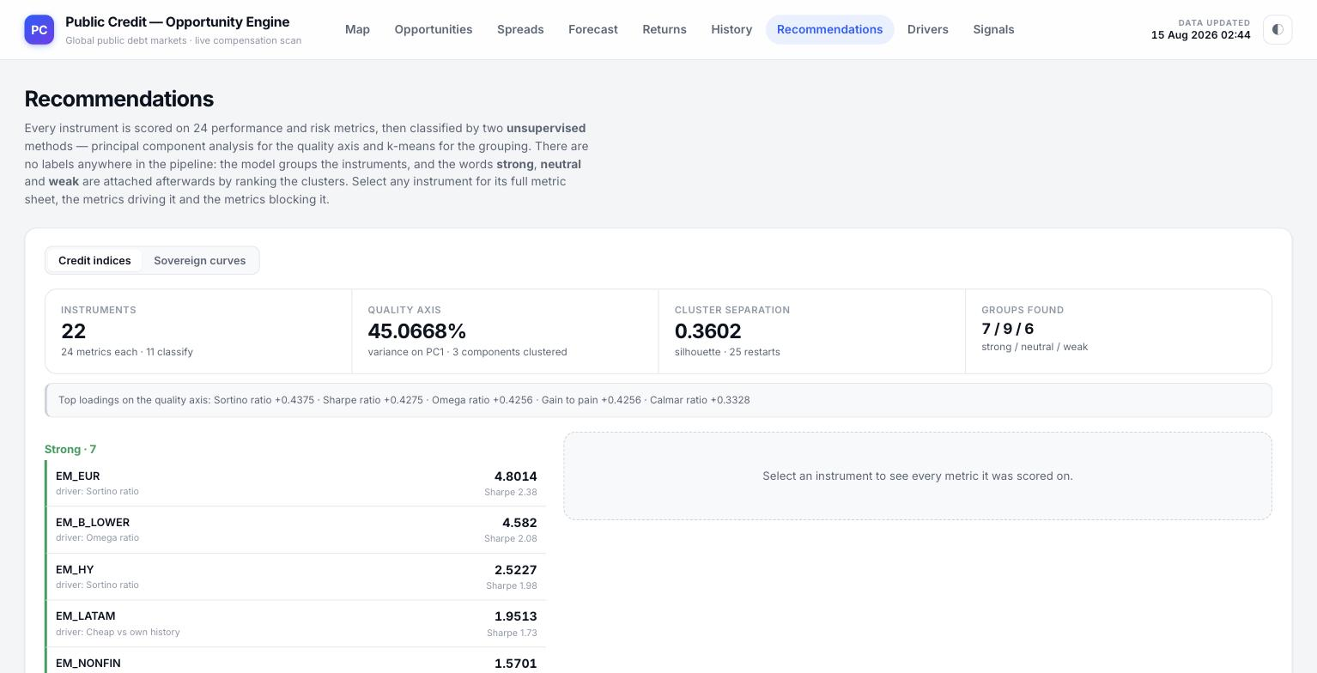
The Recommendations page on load: the pool toggle, the four model-diagnostic cards, and the Strong-tier list for the credit-index pool.

How the classification actually works
The page's own description states the method plainly: every instrument is scored on a stated number of performance and risk metrics (24 in these screenshots), then classified by two unsupervised methods — principal component analysis (PCA) to build a single quality axis out of those 24 metrics, and k-means to group instruments along that axis into three clusters. There are no labels anywhere in the pipeline; the model groups the instruments purely from the statistical structure of their own metrics, and only afterwards are the words Strong, Neutral and Weak attached, by ranking the three resulting clusters from best to worst on the quality axis the model itself found.

The pool toggle and the model-diagnostic cards
A top-level toggle switches the whole page between Credit indices and Sovereign curves, because classifying a corporate credit index against a sovereign yield curve on the same axis would compare instruments that are not naturally comparable; the two pools are always classified separately, each against its own peers only.
— Instruments — how many instruments are in the selected pool, how many metrics were computed for each, and how many of those metrics actually feed the classification.
— Quality Axis — the percentage of total variance across all instruments' metrics that the first principal component explains, together with how many components were used in the clustering step; a higher percentage means the found axis is a more confident, more dominant summary of what actually varies across the universe.
— Cluster Separation — the silhouette score of the resulting three-way grouping, a standard statistical measure of how cleanly separated the clusters are, together with how many random restarts of the clustering algorithm were run to avoid reporting a poor local solution.
— Groups Found — the resulting count of Strong / Neutral / Weak instruments (7 / 9 / 6 in the credit-index pool shown here).
A note beneath the cards states the Top loadings on the quality axis — the specific metrics (for example, in these screenshots, the Sortino ratio, the Sharpe ratio, the Omega ratio, gain-to-pain and the Calmar ratio) that most strongly define what the model's own quality axis actually represents, each with its own loading weight and sign.

The instrument list and the detail panel
The left panel lists every instrument in the selected pool, grouped under Strong, Neutral and Weak headers with a count for each, and within each group shown with its single strongest driving metric, its quality-axis score, and its Sharpe ratio as a quick reference. Selecting any instrument opens its full detail on the right.
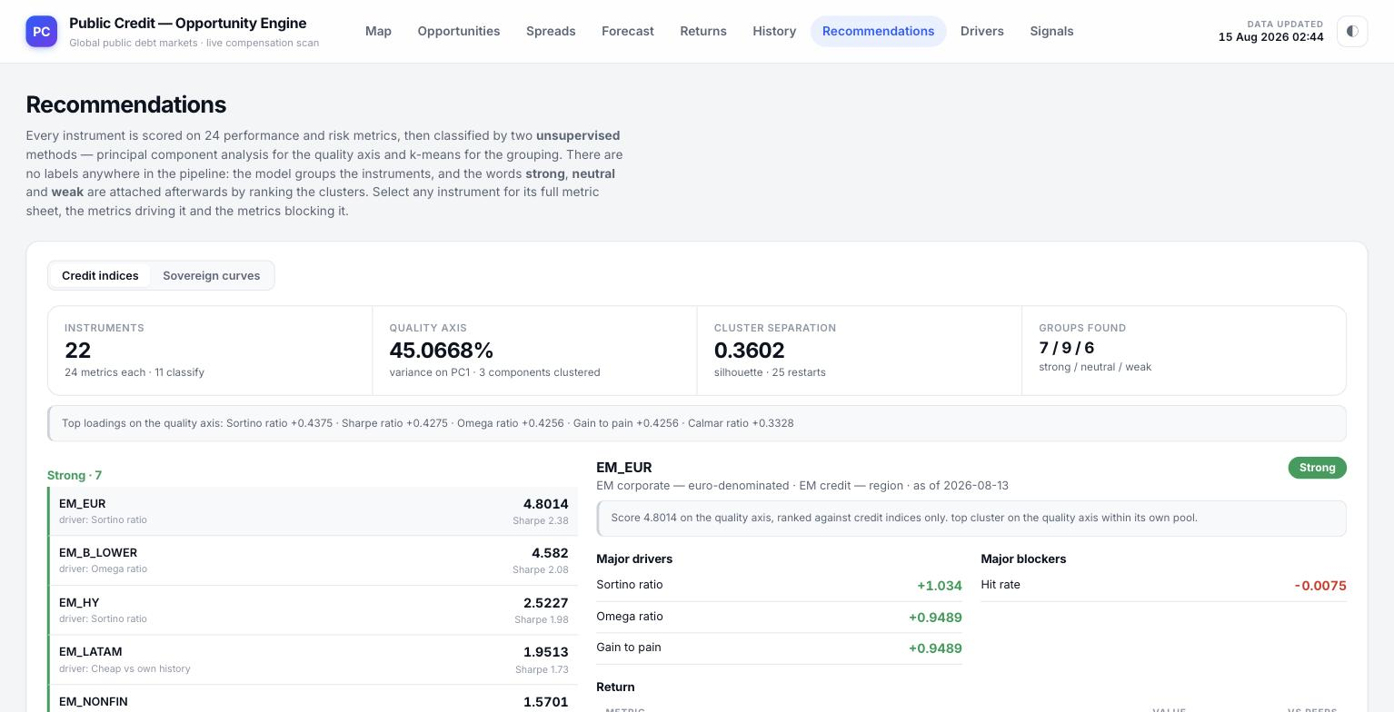
An instrument selected (EM_EUR, classified Strong): its score narrative, and the Major drivers / Major blockers columns.
The detail panel opens with the instrument's name, its classification tag, its pool, its as-of date, and a one-line narrative stating its exact score on the quality axis and how it was ranked (for example: top cluster on the quality axis within its own pool). Beneath that, two columns — Major drivers and Major blockers — name the specific metrics that most pushed this instrument's score up (shown in green, with the size of each metric's contribution) and the metrics that most held it back (shown in red), so the reader sees not just the final label but exactly which of the 24 metrics earned it.
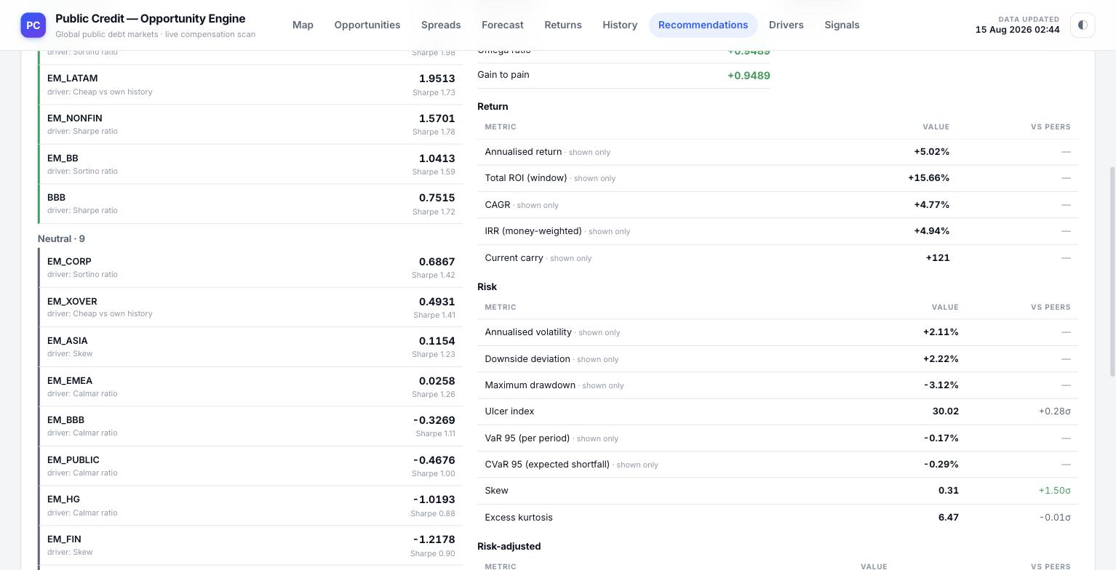
The same detail panel scrolled down into its full metric sheet, grouped by Return and Risk, each metric shown with its raw value and its standing versus peers.

The full metric sheet
Below the drivers and blockers, every one of the platform's computed metrics is listed for the selected instrument, organised into four groups — Return, Risk, Risk-adjusted and Valuation — each row showing the metric's plain-language label, its raw VALUE, and, where that metric was actually used to build the classification, its standing VS PEERS as a z-score coloured green or red. The Return group covers annualised return, total ROI over the observed window, CAGR, money-weighted IRR and current carry. The Risk group covers annualised volatility, downside deviation, maximum drawdown, the ulcer index, 95% Value-at-Risk and Conditional VaR, skew and excess kurtosis. Further groups (Risk-adjusted and Valuation, reached by continuing to scroll) cover the Sharpe, Sortino, Calmar, Omega and gain-to-pain ratios, hit rate, cheapness versus own history, carry per unit of volatility, and, for credit instruments, spread less expected loss and the cover ratio. Metrics marked shown only were computed and are displayed for completeness but were not part of the standardised set the classification itself was built from, because they still carry the raw scale of the instrument rather than being risk-normalised — exactly the distinction the platform's own quality-axis construction depends on getting right.

10. Signals — What Goes Live Next
The Signals page is the platform's own roadmap and honesty ledger for features that are built and actively accruing real data, but that are not yet shown as live figures anywhere else on the platform because they have not yet cleared the specific data condition — a gate — that each one requires before it can be trusted. The page's own framing is direct: every feature below is built and running its data accrual; it flips to LIVE by itself the moment its gate is satisfied, with no code change and no manual switch.
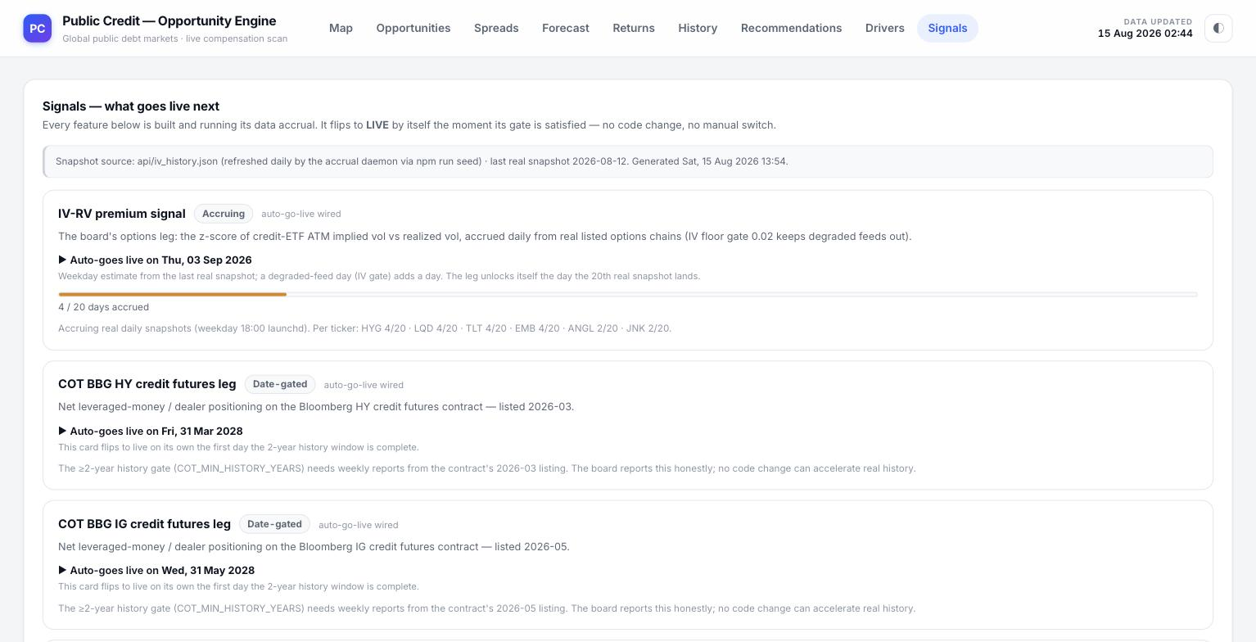
The Signals page: the snapshot-source note, the IV-RV premium signal card (Accruing), and two date-gated COT futures cards.

How to read a signal card
Every card names the feature, carries a status chip, and states in one sentence exactly what it will measure once live. Three status chips appear across the page:
— Accruing — real data is being collected daily and a progress bar shows exactly how far along the required history is (for example 4 / 20 days accrued for the IV-RV premium signal in these screenshots), with a specific estimated go-live weekday date, explicitly labelled as an estimate.
— Date-gated — the feature is waiting purely on the calendar, not on any judgement call, typically because the underlying contract needs a minimum span of history to have simply elapsed since its own listing date (for example a Bloomberg credit-futures contract needing a two-year history window to complete before its positioning data can be trusted).
— Waiting for market data — no date can be promised at all, because the gate is an external market condition rather than the passage of time — for instance, a thin options market that has not yet printed a real listed quote for the specific contract the feature needs.
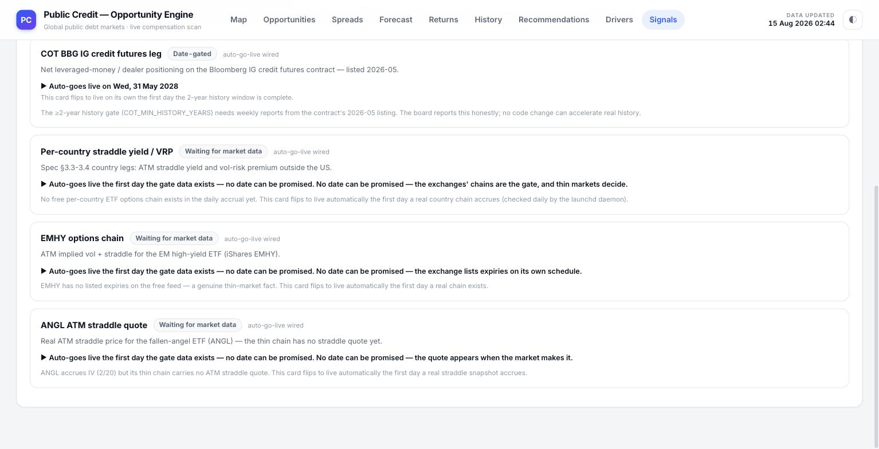
The remaining cards: a per-country volatility-risk-premium leg, an EM high-yield options chain, and an ANGL fallen-angel straddle quote, all waiting on real market data.

The individual signals shown
— IV-RV premium signal — the implied-versus-realised volatility premium on credit-ETF options, sourced from real listed option chains across a named basket of tickers (HYG, LQD, TLT, EMB, ANGL, JNK), with a floor gate on implied volatility to keep degraded data feeds out of the accrual.
— COT BBG HY / IG credit futures legs — net leveraged-money and dealer positioning on the Bloomberg high-yield and investment-grade credit futures contracts, each gated on that specific contract accumulating at least two years of listed history.
— Per-country straddle yield / VRP — the same at-the-money straddle yield and volatility-risk-premium concept used on the Returns page, extended to individual countries outside the US, gated on a free per-country options chain actually existing, which does not yet exist in the platform's free data accrual.
— EMHY options chain — implied volatility and straddle pricing for the iShares EM high-yield ETF, gated on that fund's own options exchange actually listing expiries, which it currently does not on the free feed the platform relies on.
— ANGL ATM straddle quote — a real at-the-money straddle price for the fallen-angel bond ETF, gated on that specific, thin options chain actually producing a tradeable straddle quote.
Each card ends with a short, specific explanation of exactly why that gate has not yet cleared — never a generic "coming soon" — and the page's own note at the top states its snapshot source and the exact timestamp of the most recent accrual run, so the state of every gate on this page can itself be checked against a live figure.

11. Using the Platform as a Whole
The nine pages are built to be read together, each answering a different part of the same underlying question — is this instrument compensating its holder fairly, and where is that compensation headed? Read in the order they sit in the navigation bar, they move from the broadest possible view down to the most granular:
— Map — the widest screen: which countries, across the whole world, are paying the most right now.
— Opportunities — the same question asked instrument by instrument, against each one's own trailing history, for both corporate credit and sovereign yields.
— Spreads — for the US credit ladder specifically, how much of that compensation survives after subtracting the losses a holder should statistically expect.
— Forecast — where the compensation on each rung of that ladder is statistically projected to move over the next two business weeks, and how a shock to one rung would spread to the others.
— Returns — a full forward simulation of what actually holding the instrument, or trading its volatility through a straddle, would be expected to earn or cost, net of every real friction involved.
— History — the raw, unmodelled source data everything above is built from, for a reader who wants to check the inputs directly.
— Drivers — a formal accounting of exactly how much of any one series' uncertainty is explained by shocks elsewhere in its own panel, rather than by itself.
— Recommendations — every instrument in a universe ranked against its peers, on every metric computed, by an unsupervised model with no imposed labels.
— Signals — an honest ledger of what is being built next and exactly what real-world condition each new feature is still waiting on.

What the platform is, and is not
Every figure shown anywhere on the platform is computed at request time from live public data and traces to an explicit, disclosed method — nothing is produced by an opaque model whose reasoning cannot be inspected, and nothing is backfilled, interpolated across markets, or silently estimated where no free source exists; the platform says a figure is unavailable rather than disguising a gap. Every z-score, ranking and classification on the platform is relative — to an instrument's own history, or to the other instruments in the same pool at the moment the page was loaded — and none of it is personalised, and none of it is a recommendation to transact. Removing or adding a single instrument from a classified universe can change what counts as Strong or Weak within it, precisely because the ranking is relative by construction, not an absolute judgement of quality.
This guide describes the platform's interface and outputs as observed on the live site in August 2026. The underlying figures update continuously; the controls, layout and methodology described here are what a reader will find regardless of exactly when they visit.

